eGaz, The Electronic Gazetteer
EGaz 2
Searching for a place 3
Finding nearby places 3
Displaying locations with the Map tool 3
Using Offsets 3
Finding the latitude/longitude for a known distance and direction from a named place 4
Finding the distance and direction from a named place for known latitude/longitude coordinates 4
Transferring information to other windows 5
Coordinate Calculator 5
About the current data 5
Creating eGaz gazetteer files 5
The Gazetteer database file 5
The tblDivisions table 6
The tblGaz table 6
The tblSettings table 6

EGaz
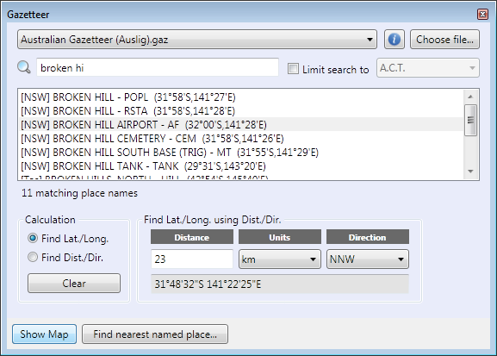
eGaz is an online, electronic gazetteer used to determine the latitude and longitude of sites. Sites can be a named place, or a locality a known distance and direction from a named place (for example 10 km NW of Abba River). eGaz can determine the latitude and longitude for both cases. eGaz can also calculate the distance and direction between a locality known only by its latitude/longitude coordinates and a named place. eGaz includes the names of places (towns, cities, mountains, rivers, etc.), the political unit to which they belong, their type (populated place, river, mountain, etc) and latitude and longitude. Once found in eGaz, coordinates can be transferred to the Rapid Data Entry and Site Details windows using drag and drop.
Selecting the View→Show Gazetteer menu opens the eGaz window if it is not already open. eGaz can also be launched from the Rapid Data Entry and Site Detail windows by clicking the ellipsis button (with the three dots) to the right of the Latitude/Longitude coordinate fields. The most recently used gazetteer file will automatically be loaded when eGaz starts. To change this gazetteer, use the Choose file… button.

Searching for a place
To find the coordinates for a site based on a named place, enter the name of the place in the Search field. Searches are case-insensitive so the use of upper or lower case letters makes no difference. As the name is entered eGaz will automatically search the gazetteer file for the closest matching named place. The results are displayed in the list near the middle of the window. This list contains all names in the gazetteer file, ordered alphabetically. The following information is recorded for each named place:
Place: The name of the place or feature.
Division: The political division or region (for example country, state, county) in which the named place is found.
Type: The nature of the named place (for example population, mountain, river).
Latitude/Longitude: The coordinates of the named place in degrees and minutes.
Once a search is complete pressing the Enter key will highlight the currently selected named place. The PgUp, PgDn and Arrow keys can then be used to scroll through the list to view other named places within the gazetteer window.
To restrict a search to named places in a subregion check the ‘Limit search to’ field and select the desired region from the picklist. Only regions present in the currently active gazetteer file will be available.

Finding nearby places
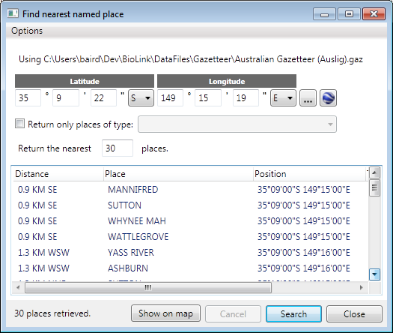
The Find Nearest Named tool window is used to, well, find the nearest named place(s) to a given location! This window is opened using the Find Nearest Named Place command on Tools→eGaz main menu.
To find nearby places, first enter the coordinates of the known place. These are entered in the Latitude and Longitude fields near the top of the window. Coordinates can be entered directly or using drag and drop from eGaz (for example, search for a known place in eGaz and then transfer its coordinates to the Find Nearest Named Place window by dragging it from eGaz to Find Nearest Named Place). The format of the coordinates, as well as the distance units, can be changed using the commands on the Options menu.
Once the coordinates are entered, enter the number of places return in the Return the Nearest … Places field and press the Search button. The length of time for the search to run will depend on the size of the database; the larger the database the slower the search. To restrict the returned places to a specific type (for example, populated places, lakes, etc.) first press the Refresh Type List button to return a list of all named place types found in the database, then click the Return Only Places of Type checkbox and select the required type in its list box. Pressing the Search button will run the search.
The results of a search will appear in the list on the bottom part of the window sorted by their closeness to the coordinates entered above. These places can be transferred to BioLink windows such as Site Details and Rapid Data Entry using drag and drop.
To show the nearby places on a map, click on the Show On Map button. The map may need to be zoomed in to see the specific points as they will almost always be very close together.

Displaying locations with the Map tool
The location of the current named place can be displayed graphically using the Map tool. To open the Map tool, press the Show Map button near the bottom of the main eGaz window. A coloured spot indicates the location of the currently selected named place. If an offset has been specified (see Using Offsets below) a second point will be displayed showing the location of this offset.

Using Offsets
Offsets are distances and directions between named places and locations. They are expressed as a distance (in kilometres or miles) and a direction (using compass points), for example ‘10 km S’ or ‘12.5 mi. SEbyE’.
Offsets can be calculated in two ways: as the latitude and longitude for a location a known distance and direction from a named place, or as the distance and direction from a location with a known latitude and longitude to a named place. The first method is used to determine the latitude/longitude for locations described as, for example, ‘10 km S of Canberra’. The second method is used when the latitude and longitude are known, as when using a GPS, and a description such as ‘10 km S of Canberra’ is required.

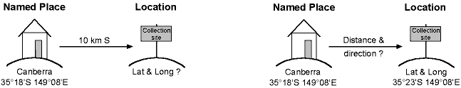

Finding the latitude/longitude for a known distance and direction from a named place
Select the Find Lat./Long. option in the Calculation group or select the Find Lat./Long. command on the Edit menu to calculate the latitude and longitude for a location a known distance and direction from the named place. This will commonly be in a form similar to ‘21 km NE of Wagga Wagga’. Information on the distance, units of measure and direction are required.
To find the offset latitude and longitude, enter the distance in the ‘Distance’ field, select the units of measure (kilometres or miles) from the Units picklist and the direction (one of 32 compass points) from the direction picklist.
Once information is entered into these three fields and a search for the (nearest) named place is completed, the latitude and longitude for the offset location will be displayed in the lower section of the Find Lat/Long using Dist./Dir. group, as well as on the status bar along the lower part of the main eGaz window. The format used in the status bar will be that specified for the custom Copy All format in the Preferences window (see Preferences Window below).
The values set in the Distance, Units and Direction fields will remain active until the Clear button is pressed, the Distance field is deleted, or the name in the Search field is replaced.

Finding the distance and direction from a named place for known latitude/longitude coordinates
Select the Find Dist./Dir. option in the Calculation group or select the Find Dist/Dir command on the Edit menu to calculate the distance and direction from a location with a known latitude and longitude to the named place selected in the gazetteer window. The latitude and longitude of the location are required.
To find the distance and direction from a named place, enter the coordinates in the Latitude and Longitude fields and select the units (kilometers or miles) from the Units picklist.
Latitude and longitude can be entered in any of three formats: degrees/minutes/seconds, decimal degrees with direction, and positive or negative decimal degrees. When using degrees/minutes/seconds, each unit is separated by a colon and the coordinates end with the direction. For example, 34 degrees, 42 minutes south latitude (34°42’S) would be entered as 34:42S, and 34 degrees, 42 minutes, 55 seconds south latitude (34°42'55"S) would be entered as 34:42:55S. When using decimal degrees, the hemisphere can be entered by appending the direction as the last character (e.g. 34.7488S) or by entering south latitudes and west longitudes as negative (e.g. -34.7488).
When both the Latitude and Longitude fields contain valid coordinates the distance and direction between the entered values and the selected named place in the gazetteer window will be displayed in the lower section of the Find Dist./Dir. using Lat./Long. group as well as on the status bar on the lower part of the main eGaz window. The format used in the status bar will be that specified for the custom Copy All format on the Preferences window (see Preferences Window below).
The values set in the Latitude and Longitude fields will remain active until the Clear button is pressed, the Latitude or Longitude fields are deleted or the name in the search field is replaced.

Transferring information to other windows
Named places are used to describe collecting sites in the Rapid Data Entry and Site Detail windows. The names of places can be typed directly in these windows or they can be entered using eGaz. The advantage of using eGaz is that spelling errors are reduced (since eGaz acts as an authoritative list) and that latitude/longitude coordinates can be automatically entered at the same time. To automatically transfer the named place along with its coordinates, locate the required place in eGaz and use drag and drop or eGaz’s Select button to transfer the coordinates to the window. During the transfer a message will be displayed asking if Locality or Named Place field should also be updated using information from eGaz. Clicking Yes will update these locality fields in addition to the coordinate fields.

Coordinate Calculator
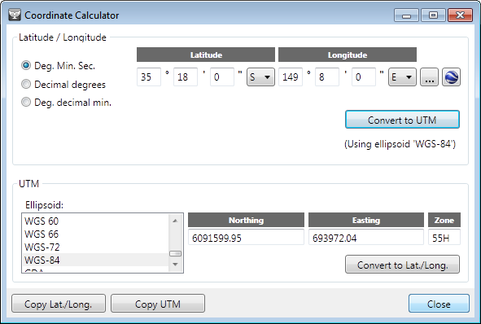
The Coordinate Calculator is used to translate between latitude/longitude and UTM or grid references (and visa versa).
To convert from latitude/longitude to UTM, enter the latitude/longitude in the upper fields, select an ellipsoid or datum and press the Convert to UTM button. Coordinates can either by entered from the keyboard or transferred from the main eGaz window using drag-and-drop. The corresponding UTM value will automatically be displayed in the lower section of the window.
To convert from UTM to latitude/longitude, enter the UTM coordinates in the lower fields, select an ellipsoid or datum and press the Convert to Lat./Long. button. The corresponding latitude/longitude values will automatically be displayed in the upper section of the window.
Once a conversion has been completed, the Copy command on the Edit menu can be used to transfer coordinates to the Clipboard for transfer to other programs.

About the current data
Information about the current eGaz gazetteer file can be found by using the About Current Data button (blue information icon). This information includes the name of the eGaz file, its version, the total number of named places and a description of the data. This information cannot be changed from within eGaz and must be changed directly in the gazetteer file using Microsoft Access.

Creating eGaz gazetteer files
Creating a gazetteer file is a moderately advanced topic and will require skills not necessary when using eGaz with existing datasets. It requires the ability to create a SQLite database with tools that are not supplied with BioLink. It may be helpful to make a copy of an existing eGaz file and use this copy (NOT the original) as an example and guide while creating new files.
For information on creating maps for the Mapping tool, see the Map Tool chapter.

The Gazetteer database file
An eGaz gazetteer database is a SQLite 3 database containing the following tables:
- tblGaz: containing named places and their latitude/longitude information
- tblSettings: containing various settings and information about the database
- tblDivisions: containing division names and their abbreviations and full names
For a gazetteer database to function within eGaz, information must be entered in each of these tables. In addition, the following indexes must be present:

Table | Index Name | Field(s) | Sort Order
tblDivision | PrimaryKey | tDatabase | Ascendng
tblGaz | Place | tPlace | Ascending
tblGaz | State | tDivision + tPlace | Ascending

NOTE: eGaz does minimal checking of data and errors in the database will generally cause eGaz to perform unpredictably or to abort loading the database.

The tblDivisions table
This table holds an abbreviation and full name for each division found in the database. It contains the following fields:
- tDatabase: the division name as used in the tblGaz table
- tAbbreviation: the division abbreviation used when copying information to the Clipboard
- tFull: the full name of the division used when copying information to the Clipboard
To function properly, there should be one record for each division name present in the database. Each of these records should have its tDatabase field set to one of the database division names. The tAbbreviation and tFull fields can then be filled with corresponding abbreviations and full names. If any of these values are missing, eGaz will default to using the division name that appears in the database. The values in this table can be viewed and/or changed within eGaz by using the Preferences command on the Edit menu.

The tblGaz table
The tblGaz table holds the list of named places found within the database along with their type, the state in which they are found and their latitude/longitude coordinates. This information is found in the following fields:
- tPlace: the named place
- tType: an indication of the type of place (e.g. town, city, mountain)
- tDivision: the division in which the named place occurs
- tLatitude: the Latitude of the place (in degrees/minutes)
- tLongitude: the Longitude of the place (in degrees/minutes)
- GazID: a system-assigned unique number
The lengths of the tPlace, tType and tDivision fields can be modified for individual databases as required. For example, the databases supplied with eGaz have the tPlace field shortened to the length of the longest place name to save space.
The tLatitude and tLongitude fields must be formatted as follows: degrees + degree mark (either ° or .) + minutes + minute mark (') + direction (a single letter). This is the only format permitted and if it is not adhered to errors in the map position and offset calculations may occur (as well as runtime errors causing the program to abort).

The tblSettings table
This table contains general settings for the database (not the program, which are placed in the system registry). The table contains the following four fields:
- SettingKey: the name of the setting item
- SettingValue: the value of the setting item if a single value or short phrase
- LongData: the value of the setting item if text-based
- UseLongData: an indication that the contents of LongData should be used rather than the value in SettingValue
The SettingKey column should contain five records, one each for the following (with the appropriate entries in the SettingValue or LongData columns):
- DatabaseName: the name of this dataset
- DatabaseVersion: the version number of this dataset
- Description: a text description of the dataset (use the column LongData if more than 255 characters are required)
- DivisonType: the type of divisions used in this dataset
- AllowEdit: when set to Yes, the names of divisions can be modified from the Preferences window
The information for the DatabaseName, DatabaseVersion and Description settings are displayed using the eGaz About Current Data command on the Help menu.

